|  |  |
| --- | --- |
| Business Analytics Skills for the Future-proofs Supply Chains - | **CASE STUDY**  **Data acquisition management and analysis**  Authors:  Roman Gumzej |

**Content**

DESCRIPTION OF THE COMPANY 3

DECISION PROBLEM 8

TASK 1 9

TASK 2 11

TASK 3 12

TASK 4 13

TASK 5 15

TASK 6 16

TASK 7 17

TASK 8 18

# DESCRIPTION OF THE COMPANY

ETI is a home appliance producer and distributor (cp. Figure 1.1, extracted from the NetLogo simulation environment). The company has multiple production sites: main site in Slovenia (SI) as well as affiliate firms in Germany (DE), Poland (PL), Hungary (H), and Bosnia–Herzegovina (BIH). In addition to production sites, its gross-sales sites are situated in Russia (RUS), Ukraine (UKR), and Romania (RU). The production sites supply their own markets with finished products and each other with product components.

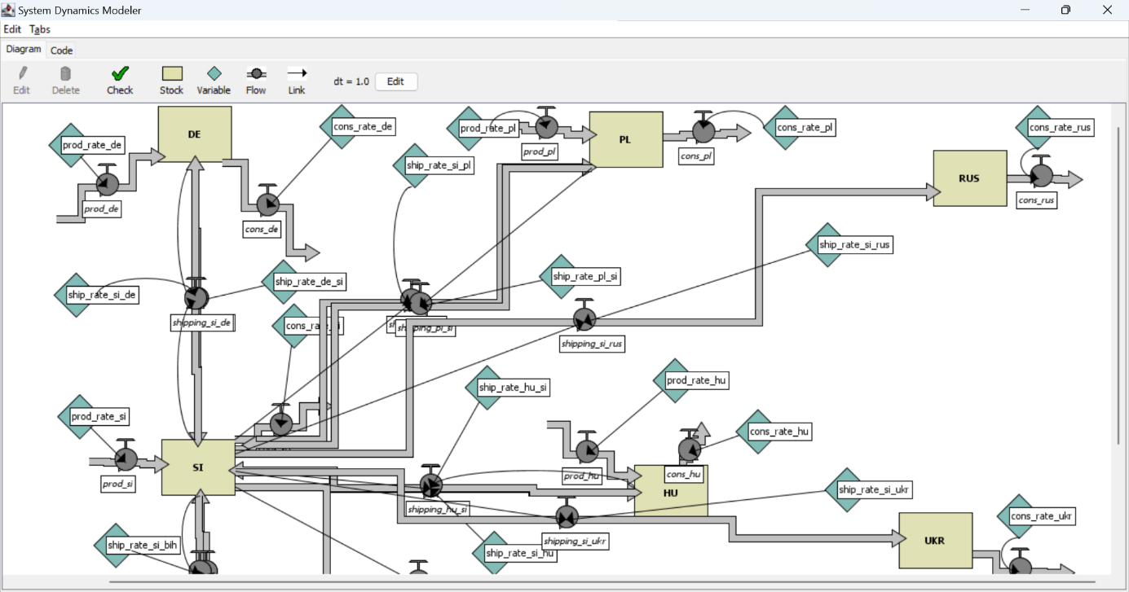

**Figure 1.1. ETI SC Layout**

Source: (Gumzej and Rakovska, 2020)

A simplified schematic of its production site in Slovenia (SI) (Figure 1.2, extracted from the JaamSim simulation environment) comprises a DES simulation model of variant production, where four main product lines are being produced. Each product type has a dedicated production line. After they are finalized, the products are checked for quality at a dedicated test site. Products of insufficient quality are transported back to the original production line. After they have successfully passed their quality control, the finished products are transported from the production site to the finished products warehouse. Re-manufacturing defective products while still in production is an effective way to reduce both environmental impacts and manufacturing costs.

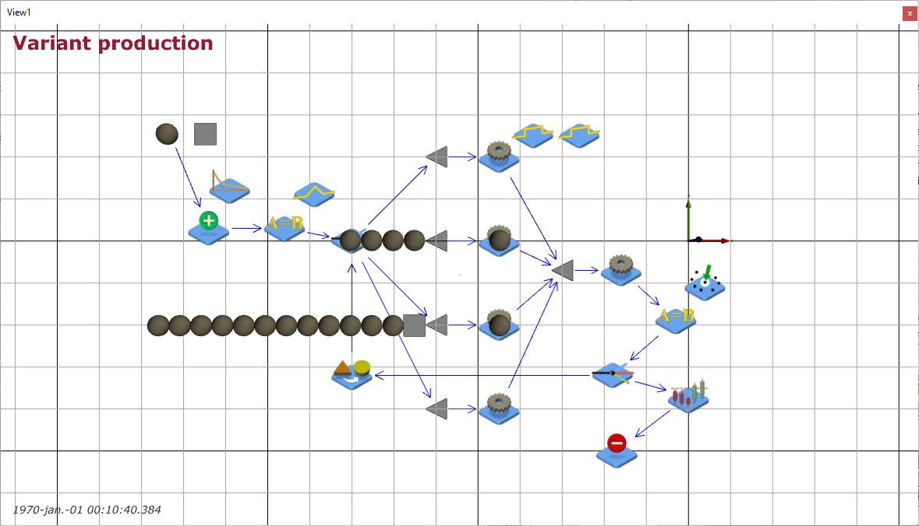

**Figure 1.2. ETI Variant production with quality control**

Source: (Gumzej and Rakovska, 2020)

The production site’s sales figures (Table 1.1), collected by the marketing department, comprise weekly sales data which helps the management to determine the busiest sites and their dominant products according to their sales portfolio.

**Table 1.1. Weekly sales data**

|  |  |  |  |  |  |
| --- | --- | --- | --- | --- | --- |
| **Date** | **Seller ID** | **Customer ID** | **Transaction ID** | **Product ID** | **Product Price** |
| 1.10.24 | 1 | 12 | 1 | 101 | 195,00 € |
| 1.10.24 | 1 | 12 | 1 | 102 | 45,00 € |
| 1.10.24 | 1 | 12 | 1 | 103 | 35,00 € |
| 1.10.24 | 2 | 14 | 2 | 104 | 55,00 € |
| 1.10.24 | 2 | 14 | 3 | 101 | 195,00 € |
| 2.10.24 | 3 | 15 | 4 | 105 | 85,00 € |
| 2.10.24 | 3 | 15 | 4 | 101 | 195,00 € |
| 2.10.24 | 3 | 15 | 4 | 103 | 35,00 € |
| 2.10.24 | 3 | 16 | 5 | 104 | 55,00 € |
| 2.10.24 | 1 | 17 | 6 | 101 | 195,00 € |
| 2.10.24 | 1 | 17 | 6 | 102 | 45,00 € |
| 2.10.24 | 1 | 17 | 6 | 105 | 85,00 € |
| 3.10.24 | 2 | 18 | 7 | 106 | 35,00 € |
| 3.10.24 | 2 | 18 | 7 | 107 | 65,00 € |
| 3.10.24 | 2 | 18 | 7 | 108 | 86,00 € |
| 3.10.24 | 4 | 19 | 8 | 105 | 85,00 € |
| 3.10.24 | 4 | 19 | 8 | 101 | 195,00 € |
| 3.10.24 | 4 | 19 | 8 | 103 | 35,00 € |
| 3.10.24 | 4 | 19 | 9 | 104 | 55,00 € |
| 4.10.24 | 5 | 20 | 10 | 105 | 110,00 € |
| 4.10.24 | 5 | 20 | 10 | 106 | 125,00 € |
| 4.10.24 | 5 | 20 | 10 | 104 | 55,00 € |
| 4.10.24 | 5 | 20 | 10 | 101 | 195,00 € |
| 4.10.24 | 1 | 21 | 11 | 102 | 45,00 € |
| 4.10.24 | 1 | 21 | 11 | 105 | 85,00 € |
| 4.10.24 | 1 | 21 | 12 | 106 | 35,00 € |
| 4.10.24 | 3 | 12 | 13 | 103 | 35,00 € |
| 4.10.24 | 3 | 12 | 13 | 104 | 55,00 € |
| 4.10.24 | 3 | 12 | 13 | 105 | 110,00 € |
| 4.10.24 | 3 | 12 | 13 | 101 | 195,00 € |
| 5.10.24 | 1 | 22 | 14 | 107 | 35,00 € |
| 5.10.24 | 1 | 22 | 14 | 108 | 25,00 € |
| 5.10.24 | 1 | 22 | 14 | 109 | 35,00 € |
| 5.10.24 | 2 | 23 | 14 | 110 | 95,00 € |
| 5.10.24 | 2 | 23 | 14 | 111 | 75,00 € |
| 5.10.24 | 3 | 24 | 15 | 112 | 125,00 € |
| 5.10.24 | 3 | 24 | 15 | 101 | 195,00 € |
| 5.10.24 | 3 | 24 | 15 | 102 | 45,00 € |
| 5.10.24 | 3 | 24 | 15 | 105 | 85,00 € |
| 5.10.24 | 1 | 25 | 16 | 106 | 35,00 € |
| 5.10.24 | 1 | 25 | 16 | 103 | 35,00 € |
| 5.10.24 | 1 | 25 | 16 | 104 | 55,00 € |
| 5.10.24 | 2 | 26 | 17 | 106 | 35,00 € |
| 6.10.24 | 3 | 11 | 18 | 105 | 85,00 € |
| 6.10.24 | 3 | 11 | 18 | 101 | 195,00 € |
| 6.10.24 | 3 | 11 | 18 | 103 | 35,00 € |
| 6.10.24 | 3 | 11 | 18 | 104 | 55,00 € |
| 6.10.24 | 4 | 12 | 19 | 105 | 110,00 € |
| 6.10.24 | 4 | 12 | 19 | 106 | 125,00 € |
| 7.10.24 | 2 | 27 | 20 | 107 | 65,00 € |
| 7.10.24 | 2 | 27 | 20 | 108 | 86,00 € |
| 7.10.24 | 2 | 27 | 20 | 105 | 85,00 € |
| 7.10.24 | 2 | 27 | 20 | 101 | 195,00 € |
| 7.10.24 | 1 | 28 | 21 | 103 | 35,00 € |
| 7.10.24 | 1 | 28 | 21 | 104 | 55,00 € |
| 7.10.24 | 1 | 28 | 21 | 106 | 35,00 € |

Source: (own)

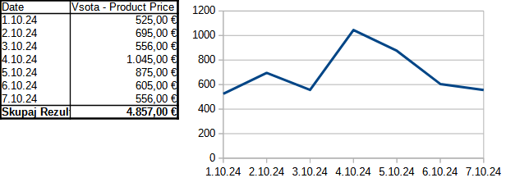**Figure 1.3. Sales statistics by weekday**

Sales statistics by weekday (Figure 1.3) enables production planning.

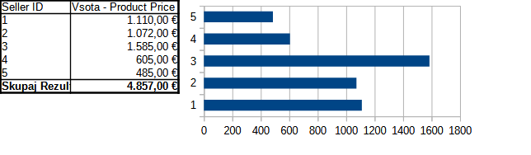

**Figure 1.4. Sales statistics by sales-office**

Sales statistics by company (Figure 1.4) determines the market requirements.

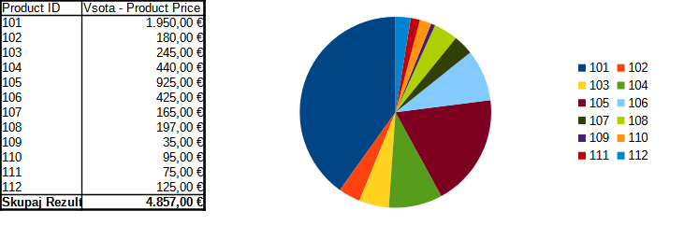**Figure 1.5. Sales statistics by product**

Sales statistics by product (Figure 1.5) determine the products that are most sought for or represent a significant share in the ETI portfolio.

# DECISION PROBLEM

The problems in supply chain management pertain to all three levels of decision making:

* Strategic, where managers mainly decide on „what is to be done”;
* Tactical, where the management determines „how it can be done”;
* Operational, where management determines whether all resources are available and whether the capacities are sufficient.

The main questions are usually resolved in the following order:

1. Which products or locations should be promoted?
2. What is necessary to achieve this goal?
3. Which capacities and resources should be provided?
4. Are the envisaged plans being fulfilled?

The order resembles the Deming’s „plan-do-check-act” cycle, as discussed in the Introduction to Operations Research chapter:

1. Data collection and preparation
2. Business analytics
3. Capacity planning
4. Simulation modelling and analysis
5. Fulfilment

The tasks involved require knowledge from chapters Data management, Simulation Modelling and Analysis as well as Introduction to operations research.

Tasks 1 and 2 address Step 1 – data collection and preparation.

Tasks 3, 4 and 5 address Step 2, 3 and 4 – business analytics, capacity planning, simulation modelling.

Tasks 6, 7, and 8 address Steps 4 and 5 – analysis and fulfilment.

# TASK 1

Collect and prepare the sales data for analysis. In order to fulfil the task, use the enclosed transaction data. There are several steps involved:

1. Import the DM (2024).cvs data into the spreadsheet application of choice.
2. Filter out empty cells and unbiased data.
3. Transfer data into a fresh spreadsheet for business analytics.

Ad 1) Please note that while importing it is necessary to ensure that the first line includes data attribute names, and the rest include appropriate lines with data. Note the separator between data, which in this case is a comma.

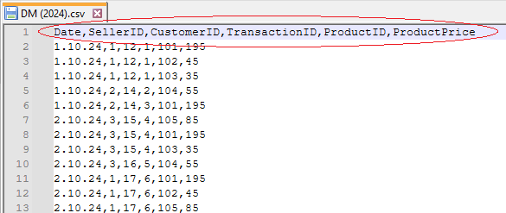

Ad 2) After importing, count the lines of data in each column to determine empty cells. Expose biased data by calculating the maximum and minimum data values.

When ready, use spreadsheet filter tools to rule out unbiased data.

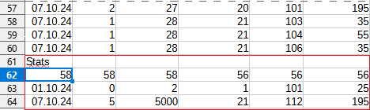

Ad 3) Copy and paste the filtered data into a fresh spreadsheet for further processing.

|  |  |
| --- | --- |
|  | Note that You can detect missing and unbiased data by determining the minimum and maximum column values.  Filter out correct data by using the spreadsheet’s built-in filter functions. |
|  | [DM (2024).csv](https://univerzamb-my.sharepoint.com/personal/roman_gumzej_um_si/Documents/Izobraževanje/Učbeniki%202024/Book3/Use-case%201/DM%20(2024).csv)  [DM (2024).ods](https://univerzamb-my.sharepoint.com/personal/roman_gumzej_um_si/Documents/Izobraževanje/Učbeniki%202024/Book3/Use-case%201/DM%20(2024).ods) |

NOTES

# TASK 2

Build a database from the collected data for easier exploration and maintenance. Perform some basic searches to demonstrate knowledge discovery. Determine:

* The busiest days.
* The busiest locations.
* The critical products.

You can perform the searches by selecting appropriate fields (e.g., date and product price) and using aggregate functions such as counting and summation.

What else could You determine from existing data? How could You extend it?

|  |  |
| --- | --- |
|  | In order to build a database, create it and import spreadsheet data by copy-pasting it as a new table. |
|  | [DM (2024).odb](https://univerzamb-my.sharepoint.com/personal/roman_gumzej_um_si/Documents/Izobraževanje/Učbeniki%202024/Book3/Use-case%201/DM%20(2024).odb) |

NOTES

# TASK 3

Perform business analytics on the collected data using pivot tables. The results should resemble the data and graphs, as given in the problem description. Determine:

* The busiest days.
* The busiest locations.
* The critical products.

What else could You determine from the collected data?

|  |  |
| --- | --- |
|  | Use the results from Task 1. |
|  | [BA (2024).ods](https://univerzamb-my.sharepoint.com/personal/roman_gumzej_um_si/Documents/Izobraževanje/Učbeniki%202024/Book3/Use-case%201/BA%20(2024).ods)  [BA (2024).xlsx](https://univerzamb-my.sharepoint.com/personal/roman_gumzej_um_si/Documents/Izobraževanje/Učbeniki%202024/Book3/Use-case%201/BA%20(2024).xlsx) |

NOTES

# TASK 4

Check the resources required and perform capacity planning. See, what production quantities fulfil the market requirements of the ETI supply chain?

Weekly sales statistics by number of products sold for the different ETI locations are:

* SI (production & sales): 18,
* DE (production & sales): 12,
* PL (production & sales): 16,
* H and BIH (production & sales): 6,
* RUS, UKR and RU (sales): 4.

|  |  |
| --- | --- |
|  | Use the [NetLogo](https://ccl.northwestern.edu/netlogo/#:~:text=NetLogo%20is%20a%20free%20software%20for%20creating%20and%20running) simulation environment.  Fine tune the parameters to match Your case. |
|  | [ETI_big.nlogo](https://univerzamb-my.sharepoint.com/personal/roman_gumzej_um_si/Documents/Izobraževanje/Učbeniki%202024/Book3/Use-case%201/ETI_big.nlogo) |

NOTES

# TASK 5

Parameterize the DES model to determine production times and volumes for location SI. Group product types accordingly to achieve a balanced load distribution.

Sales statistics by product (Figure 1.5) determines the products that are most sought for or represent a significant share in the ETI portfolio. According to these statistics, the production plan comprises some 10, 30, 40, 20% of product types 1, 2, 3, and 4, respectively:

* Type 1 (10%): 106, 107, 108, 109, 110, 111.
* Type 2 (30%): 105.
* Type 3 (40%): 101.
* Type 4 (20%): 102, 103, 104.

They are produced at the corresponding production lines 1-4 within each production branch of the ETI group. Each product type has a dedicated production line. Choosing a product type is induced by the triangular distribution between 1 and 4 with modulo at 3. According to sales statistics, the production orders are fulfilled according to the exponential distribution with 60-minute minimum and 480-minute maximum time between orders and 120 minutes average interarrival time. The production of every single product takes 100–120 minutes according to the uniform distribution. After they are finalized, the products are checked for quality at a dedicated test site. The quality check takes 150 minutes. From the company’s experience, on average every 1 out of 10 products doesn’t pass inspection. Products of insufficient quality are transported back to the original production line. Their reprocessing takes 120–130 minutes according to the uniform distribution. The durations of production and quality inspection and reprocessing don’t depend on product type.

|  |  |
| --- | --- |
|  | Use the [JaamSim](https://jaamsim.com/#:~:text=JaamSim%20is%20a%20free,%20open%20source%20software%20for%20building%20and) simulation environment.  Fine tune the model parameters to match Your case. |
|  | [Variant_Production.cfg](https://univerzamb-my.sharepoint.com/personal/roman_gumzej_um_si/Documents/Izobraževanje/Učbeniki%202024/Book3/Use-case%201/Variant_Production.cfg) |

NOTES

# TASK 6

Analyse simulation results to make recommendations on production capacities:

* At which rates should the individual lines process production orders in order to fulfil demand and prevent bottlenecks?
* Is one quality control department enough?
* What is the production cycle length?
* How does the order of production-order fulfilment affect cycle length?

|  |  |
| --- | --- |
|  | Use the results produced by the simulation environments in Tasks 4 and 5.  Note the results and formulate recommendations accordingly. |
|  | [Variant_Production.rep](https://univerzamb-my.sharepoint.com/personal/roman_gumzej_um_si/Documents/Izobraževanje/Učbeniki%202024/Book3/Use-case%201/Variant_Production.rep) |

NOTES

# TASK 7

Analyse simulation results to make recommendations on production capacities:

* Is the grouping of products to product types appropriate?
* Is the distribution of production facilities appropriate?
* Are there any bottlenecks and how could they be avoided?

Note the results and formulate recommendations accordingly.

|  |  |
| --- | --- |
|  | See the results from Task 6. |

NOTES

# TASK 8

Devise an action plan the management should fulfil on the strategic, tactical as well as operational levels according to the DFSS paradigm.

What have You learned? What information do You still miss?

|  |  |
| --- | --- |
|  | Use the results from previous tasks. |

NOTES

Business Analytics Skills for the Future-proofs Supply Chains -